**UMGC City Team 1 Project Requirements by Israel Del Toro (Primary Client)**

The following statements are excerpted from email response from our project client detailing the software requirements needed for UMGC City Application of SWEN 670 Spring 2020 Capstone Course.

**Excerpt 1**

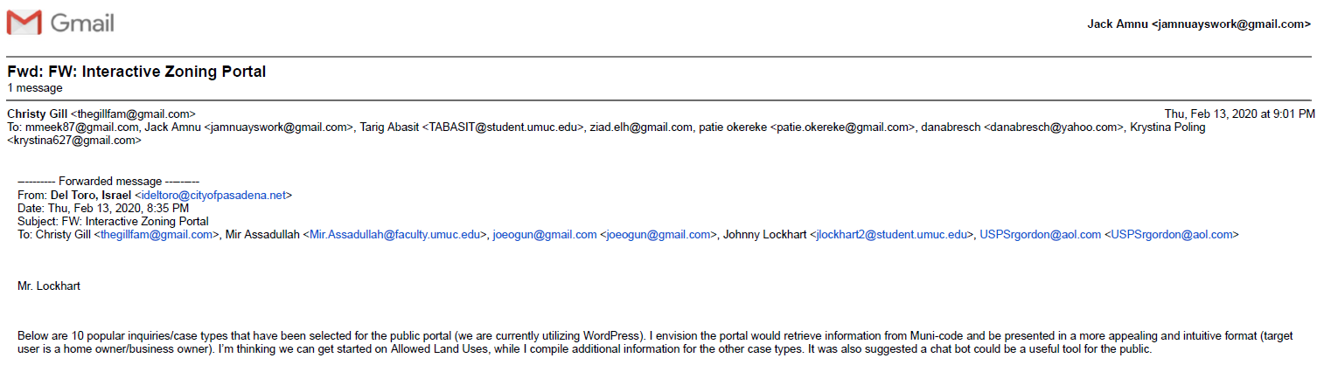

Final Project Deliverables:

Team 1’s Admin Portal database contains all relevant use case information from the 10 popular inquiries specified and can be accessed via the Quick Reference Page that is geared toward the city resident users with user-friendly and intuitive format design. ChatBot mentioned is handled by Team 2.

**Excerpt 2**



Final Project Deliverables:

The primary focus on Team 1’s map/web interfaces of UMGC City Application is on enabling the interactive customer-facing HTML map. Team 1 agrees that given project resources and time, the ability to search the map with a specific address within various city zone parcels is a huge undertaking that lies beyond the scope of this course. However, both Team 1 and Team 2 come to an agreement in which Team 2 would tackle the feature of searching Allowed Land Uses (Parcel Specific) by address via ChatBot, as its purpose of the application is more aligned than the map. Besides the map hovering feature, Team 1 has implemented every requirements, including the proper definitions of land use, access entitlement process and requirements (e.g. Conditional Use Permit), and link to application. Team 1 extensively datamines the Municode website to obtain all required data that results in the table containing more than 23,000 rows of useful city columns. The Permit Center hours for no cost over the counter consultation and phone number for the planner of the day are included in Team 1’s early mock-up prototypes but never made it to the final version due to manpower and time constraints.

**Excerpt 3**



Final Project Deliverables:

Team 1’s overall approach to the map design is to break down each area (zone) within the Pasadena according to its labeled zone codes and associated areas using the existing City of Pasedena maps, APIs, and resources (Municode tables, etc.) as the guidance. Due to the lack of subject matter experts and too large of project scope, Team 1 forgoes the use of area parcels. In addition, Team 2 is more suited and dedicated to retrieve the Allowed Land Uses (Parcel Specific) based on specific addresses within the area parcel (see the example below).

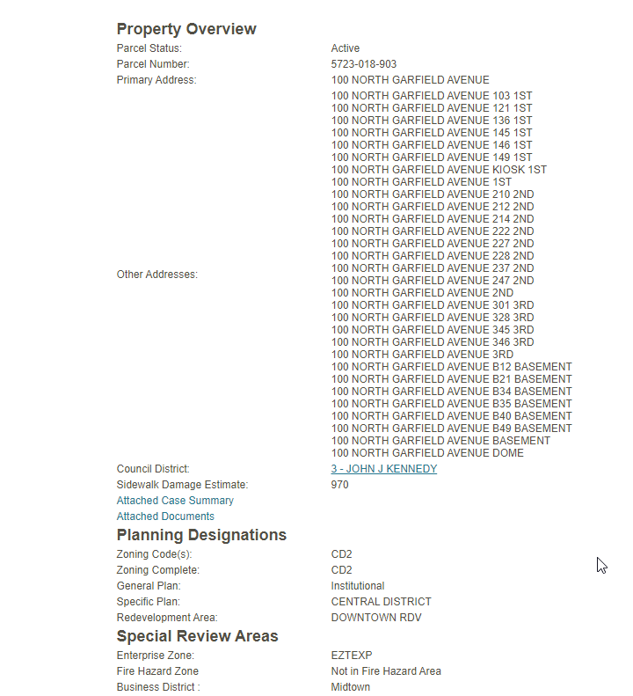

Team 1 instead focuses on datamining the available tables from the Municode website into usable data format that can be dynamically integrated into our database (see the example of such table below). In addition to linking the land uses to each zone codes, we provide zone mappings to all applicable data including the proper definitions of land use, access entitlement process and requirements (e.g. Conditional Use Permit), and link to application. This results in more value added features that could be incorporated into existing city portal as mentioned by our client.

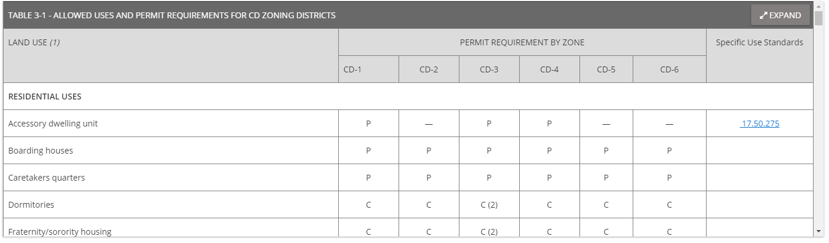

**Excerpt 4**

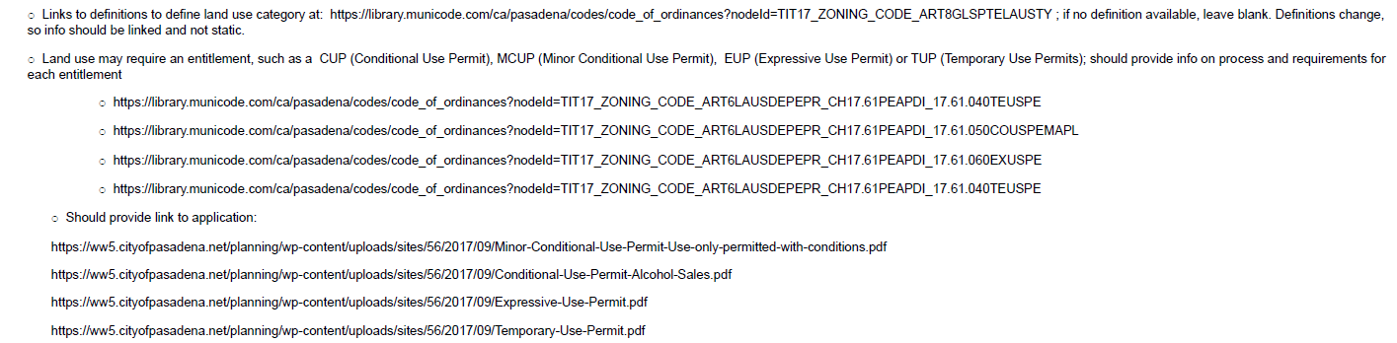

Final Project Deliverables:

Team 1 has successfully tackled the project requirements seen in the excerpt above using thorough datamining with a lot of manpower hours. Definitions of land use, access entitlement process and requirements (e.g. Conditional Use Permit), and link to application are painstakingly researched and appropriately mapped to each zone within the City of Pasadena. Our Heroku cloud Postgres database contains this information.

**Excerpt 5**

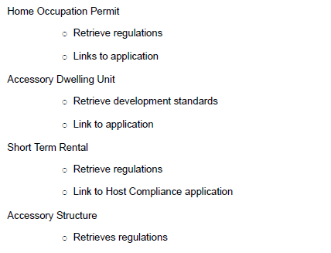



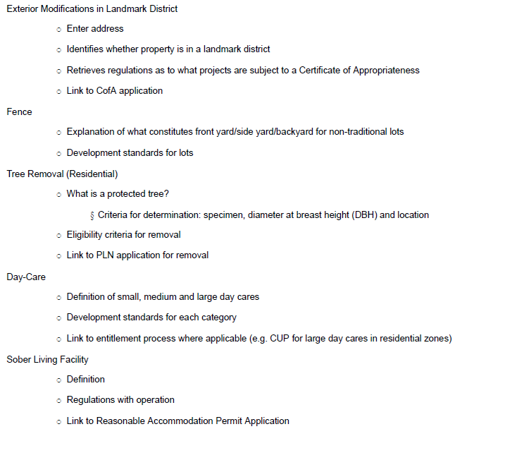

Final Project Deliverables:

The Quick Reference Page created by Team 1 creates an appealing and intuitive way for city resident users to quickly search for the 10 most popular inquiries as specified by our client (Allowed Land Uses, Home Occupation Permit, Accessory Dwelling Unit, Short Term Rental, Accessory Structure, Exterior Modification in Landmark District, Fence, Tree Removal (Residential), Day-Care, and Sober Living Facility). For each of these 10 use cases, we have streamlined the process of presenting data in a universal way within the Quick Reference Page using proper links. They include, but not limited to, definitions of land use, access entitlement process and requirements (e.g. Conditional Use Permit), and link to application.